

Keycloak Configuration Handbook
Reportnet 3.0 Design and Development

Date: 22/07/2020
Doc. Version: v0.2

Document Control Information

Settings | Value
Document Title: | Keycloak Configuration Handbook
Project Title: | Reportnet 3.0 Design and Development
Document Author: | Jose Luis Antón Bueso
Leader | Xxxxxxxx
Reviewer | Xxxxxx
Project Owner: | Stefan Jensen
Business Manager (BM): | Jonathan Maidens
Solution Provider (SP): | Søren Roug
Project Manager: | Christian-Xavier Prosperini
Doc. Version: | v0.2
Sensitivity: | : <Public, Limited, High>
Date: | 22/07/2020

Document Approver(s) and Reviewer(s):
Name | Role | Action | Date
 | Project owner | Review
Christian Xavier Prosperini | Project manager | Review/Approve

Document history:
The Document Author is authorized to make the following types of changes to the document without requiring that the document be re-approved:
- Editorial, formatting, and spelling
- Clarification
To request a change to this document, contact the Document Author or Owner.
Changes to this document are summarized in the following table in reverse chronological order (latest version first).
Revision | Date | Created by | Short Description of Changes
0.1 | 23.08.2019 | Jose Luis Antón Bueso | Initial draft
0.2 | 22.07.2020 | Jose Luis Antón Bueso | Review configuration data as well as integration with EuLogin.

TABLE OF CONTENTS
Table Of Content
1 About this document 4
1.1 Assumptions 4
1.2 References 4
1.3 Terms, acronyms and abbreviations 4
2 Introduction 4
2.1 Keycloak Basic Concepts 4
3 Keycloak Configuration 5
3.1 Configuring Admin user 5
3.2 Access admin console 5
3.3 Configuring Reportnet 3.0 6
3.3.1 Realm 6
3.3.2 Roles 7
3.3.3 Client 8
3.3.4 Identity Provider 10
3.3.5 Automatic Login 12
3.3.6 User Configuration 13

About this document

This document will show how to configure Keycloak in order to provide the functionality that Reportnet 3.0 requires from this tool. The main points to be covered are the following ones:
- Basic concepts to understand how Keycloak works
- Admin User Configuration
- Configuration for client application Reportnet
- Resources Configuration
- Groups Configuration
- Policies and Permissions configuration
- CAS Based Authentication configuration
- Environment Migration

Assumptions
This Document is based on the Keycloak_Integration_Feasibility_Study document.

References
Ref. | Version | Location
[R1] | 0.01 | Keycloak Integration Feasibility Study
[R2] | 1 | TRACASA-ALTIA-RN3-Technical_architecture_v1

Terms, acronyms and abbreviations
Term | Description
IAM | identity and access management
SSO | Single Sign On
UMS | Reportnet User Management Service

Introduction
Keycloak is an open source Identity and Access Management solution aimed at modern applications and services. In the context of Reportnet 3.0 it will act as User database as well as provider of Authentication and Authorization services.

Keycloak Basic Concepts
Realm: A realm manages a set of users, credentials, roles, and groups. A user belongs to and logs into a realm. Realms are isolated from one another and can only manage and authenticate the users that they control
Client: Clients are entities that can request Keycloak to authenticate a user. Most often, clients are applications and services that want to use Keycloak to secure themselves and provide a single sign-on solution. Clients can also be entities that just want to request identity information or an access token so that they can securely invoke other services on the network that are secured by Keycloak
Resource: Represents a Resource to be protected: Dataflow, Dataset, Schema… Only object, not instances. Dataflow_1 is not a Resource, /dataflow is a resource
Scope: Mean an action to be performed on a Resource. Is a verb: READ, UPDATE, DELETE…
Policy: Is a precondition that must be fulfilled before a user is able to perform an action on a Resource. The Resource itself is not part of a Policy.
Role: identify a type or category of user. DATA_CUSTODIAN, DATA_PROVIDER…
User: Represents a EEA’s User.
User Group: Is a group of Users with the same Role/Roles
Permission: Is the association of a Resource, a Policy and a Scope
Identity Provider (IDP): is a service that can authenticate a user. Keycloak is an IDP. In Reportnet 3.0, Keycloak will delegate in EU Login as the main IDP to provide Authentication for users via CAS Protocol.

Keycloak Configuration

Configuring Admin user
First thing is to set up de admin user in the main realm called “master”. To do this is enough to invoke to:
/bin/add-user-keycloak.sh -r master -u <username> -p <password>
Once the admin user is created reboot the server and Keycloak will be ready to be accessed by the admin user

Access admin console
Type the following address in the browser: http://<keycloakIp>:<keycloakport>/auth and click on “Administration Console”. Then the following screen will be shown:
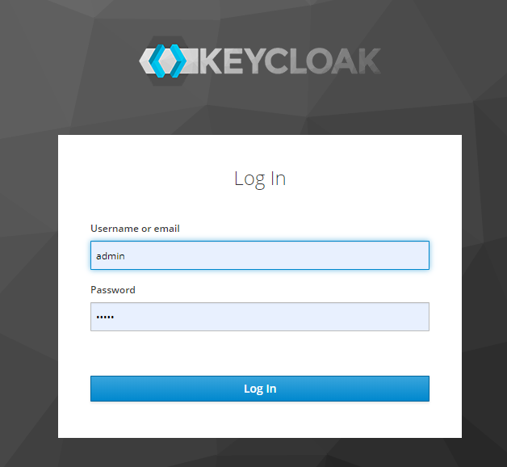
Insert the admin’s name and password and the administration console will be show
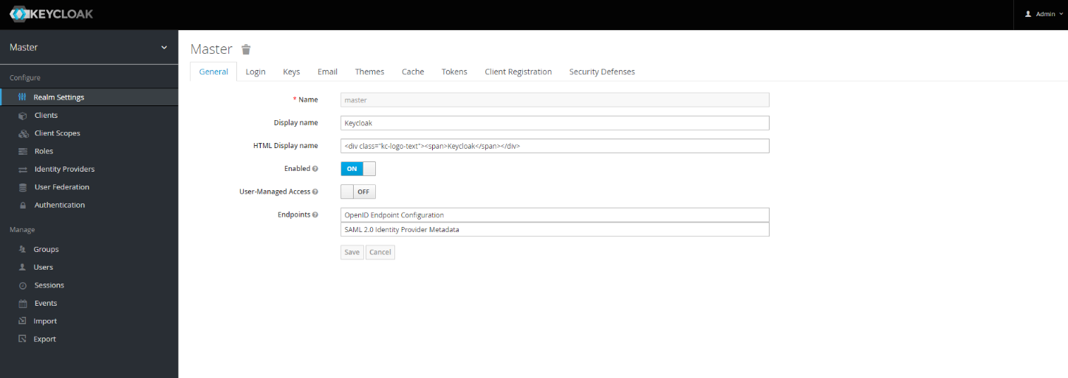

Configuring Reportnet 3.0

Realm
The First thing is to create the Realm for Reportnet as It is not a good practice to work con Master realm so click on the arrow beside the name of the Realm (Master) and click on button “Add realm”
Fill the info as shown:
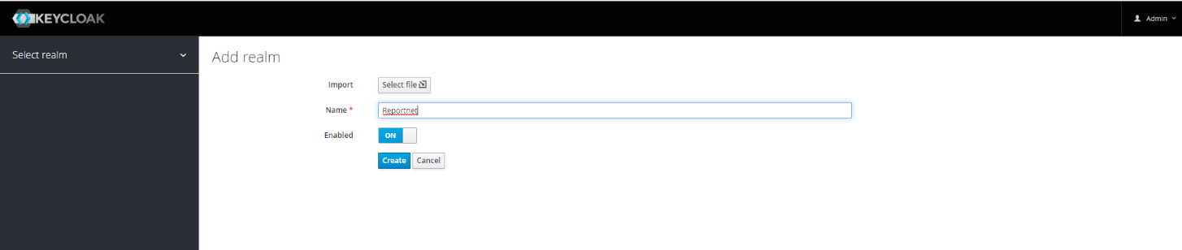
After that, edit the Realm and check the use of SSL as none:
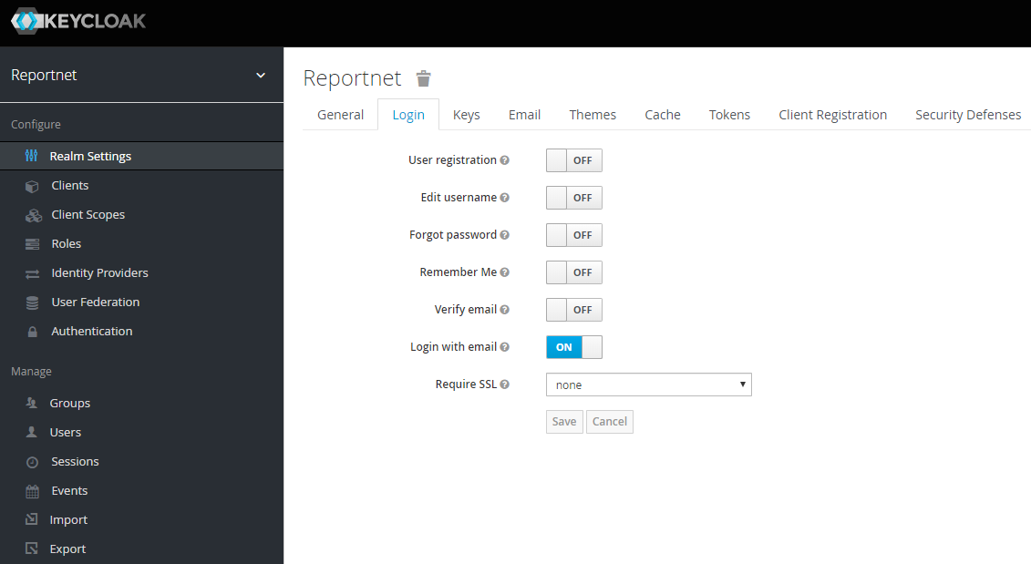
Now click on Keys tab, and then on public key button to get the public key:
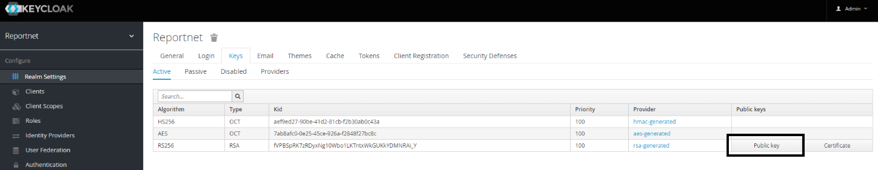

This key will be part of the configuration of Reportnet.

Roles
Once the Realm is created it is necessary to create the Roles. For that, click on left menu “Roles” and then click on button “Add role”. The following sreen will be shown:
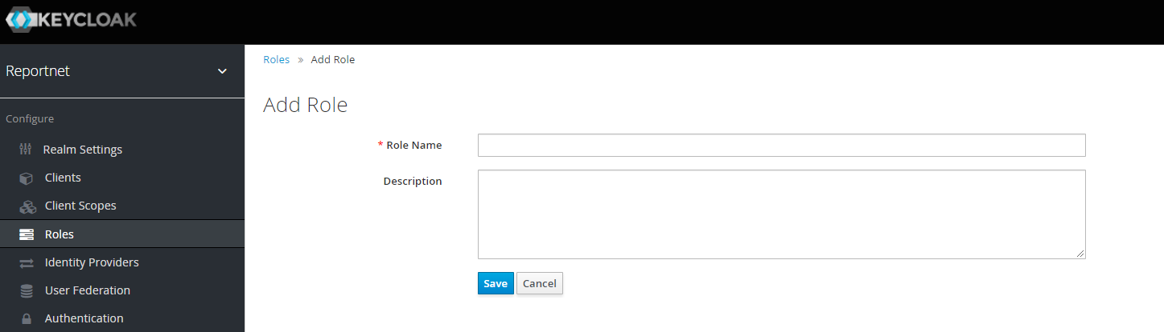
Below Is the list of roles to create:
- DATA_STEWARD
- DATA_CUSTODIAN
- DATA_PROVIDER
- DATA_REQUESTER
- DELEGATE_DATA_PROVIDER

Client
Once the realm and roles are created it is necessary to create the Client, the entity that will authenticate the user
Click on left menu “Clients” and then on button Create:
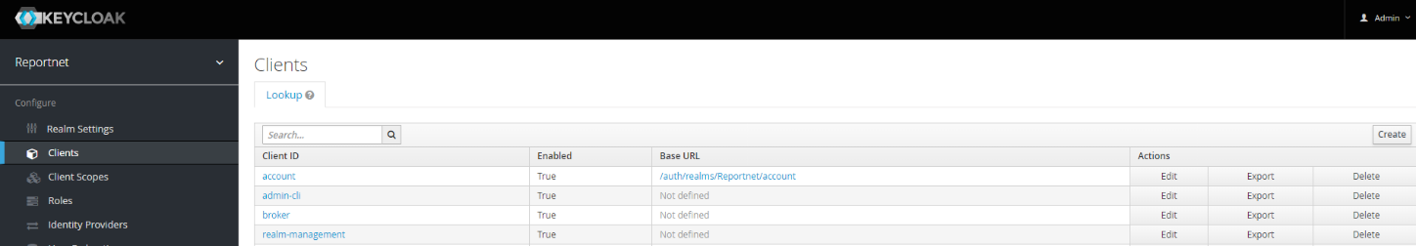
Fill the form as follows:
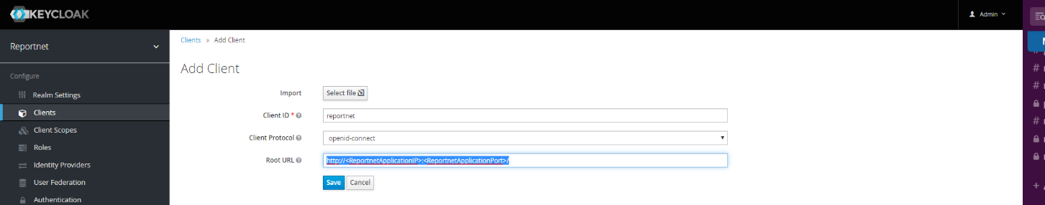
Then, back to the clients list (left menu “Clients”) click on the new one and fill the form as follows
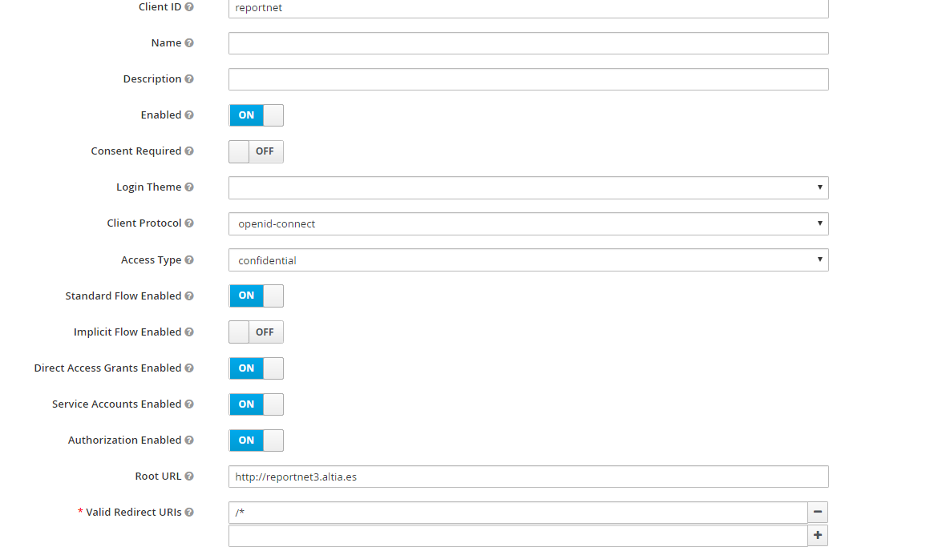
Note: on Altia dev env, Root URL is http://reportnet3.altia.es and Valid Redirect URIs should be /*. This way it will be easier to redirect to the proper views when the user logs in or logs out.
Now credentials for that Client must be set up. For that click on tab “Credentials”. Click on Regenerate Secret. A new secret will be configured:
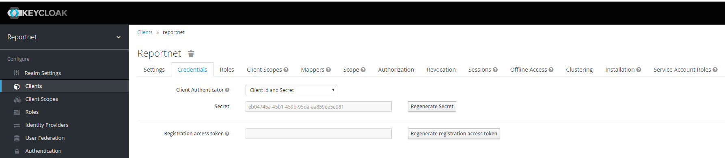
Take note of this “Secret” since it will be part of the Reportnet’s configuration.
Authorization Configuration can be set up now. For this, navigate to tab “Authorization” on Client Reportnet details screen.

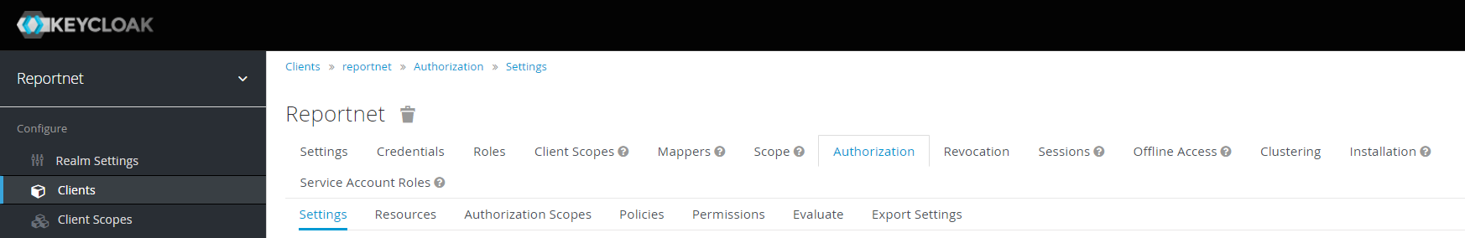

Identity Provider
The Identity Provider will be the module responsible to solve the connection between Keycloak and EU Login via OpenId Protocol.

Navigate to Identity Provider left menu and Select “OpenId Connect v1.0”
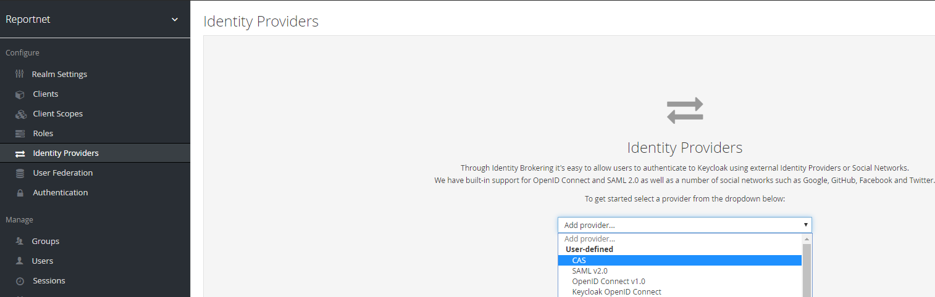
Configure the provider as follows:
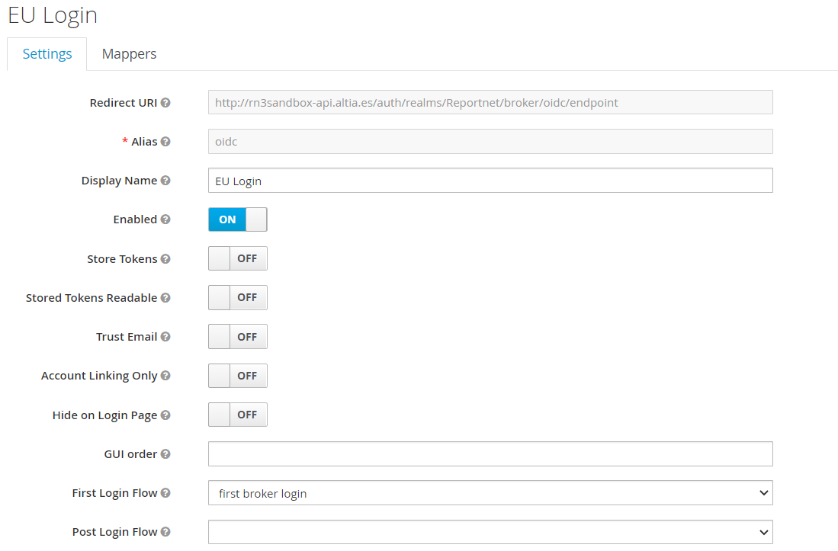
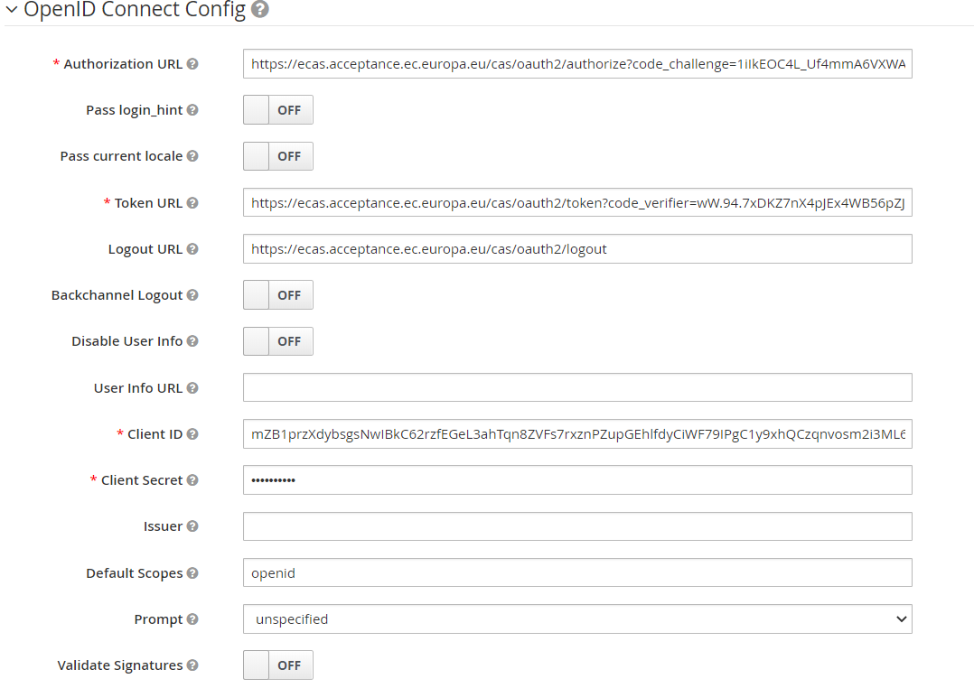
Authorization URL field: it needs to be configured with the appropriate url that DIGIT provides on its web page.
Also a code_challenge needs to be created to be attached to the Authorization URL. This code_challenge can be created here: https://tonyxu-io.github.io/pkce-generator/
Finally code_challenge_method must be provided with value S256.
The complete Authorization URL field would look as follows for EU Login Acceptance environment: https://ecas.acceptance.ec.europa.eu/cas/oauth2/authorize?code_challenge=1iIkEOC4L_Uf4mmA6VXWAHAEo_nexTOdaLjBQDfo0xc&code_challenge_method=S256
Token URL field: it needs to be filled with the url provided by DIGIT along with the code verifier generated on https://tonyxu-io.github.io/pkce-generator/ (it is important to create a pair code_challenge and code_challenge_verifier)
The Token URL for EU Login Acceptance Environment would look as fallows: https://ecas.acceptance.ec.europa.eu/cas/oauth2/token?code_verifier=wW.94.7xDKZ7nX4pJEx4WB56pZJqH9RtjTv5bOYPHV_P5CuSZeaanL40g9Y8jl69akjE99ahmYjSW~6jgQUAhUbKPBj_gbX5C4KRqjne-eC9wwS8Gc1Qxmg3SQKcnm9f
Logout URL field: it needs to be filled with the URL provided by DIGIT
Client Id and Secret field: These data must be provided by DIGIT. For DIGIT to provide them it is necessary to create register Reportnet as an Application that will use EuLogin as Authentication Platform. More data about this here: https://webgate.ec.europa.eu/CITnet/confluence/display/IAM/OpenID+Connect+endpoints
Note: The EuLogin base URL for production environment is https://webgate.ec.europa.eu/
Now Keycloak is ready to authenticate via OpenId. In order to check configuration click on the following url.
http://<keycloakIp>:<keycloakPort>/auth/realms/Reportnet/protocol/openid-connect/auth?client_id=reportnet&redirect_uri=http%3A%2F%2Freportnet3.altia.es%2Fdata-flow-task%2F&state=1489230d-c1b1-4e25-8b85-1f9a5b109171&response_mode=fragment&response_type=code&scope=openid&nonce=a6f26ddc-2af5-4f7c-910d-5bb3b344421e
The following form should be displayed:
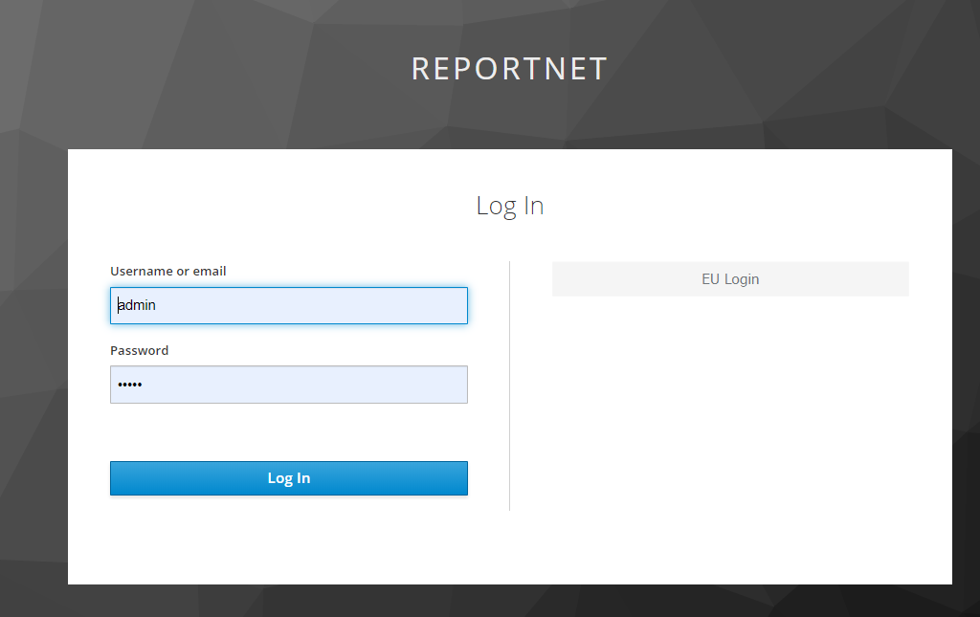

Click on EU Login and to get redirected to EU Login log in web page. Once the user is Authenticated it will be redirected to Reportnet home page.

Automatic Login
It is possible to configure Keycloak to redirect the user straight to EU Login without clicking on “EU Login”. To do this:
Click on Left Menu on Authentication option. Then click on Actions in the line “Identity Provider Redirector”
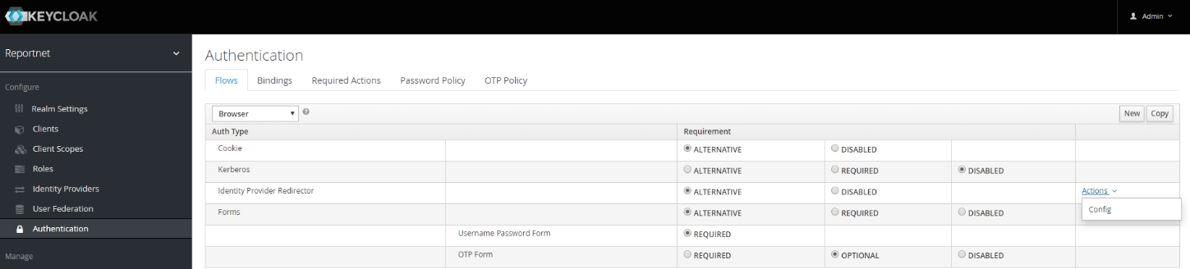

In the form add a name for the redirector and the name of the Identity Provider (cas):
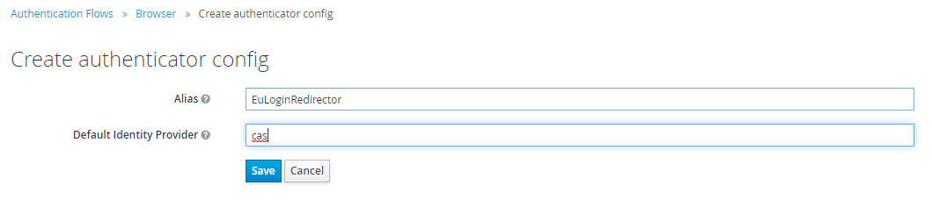
Now when some user wants to login in Reportnet he will be redirected to EU Login without seeing the Keycloak screen.
Note: It is very important to configure this Authentication method for reportnet and not for the admin client since we would lose the access to admin console.

User Configuration
The first user that must be set up is “reportnet_user”. This user will be used by User Management Service to interact with Keycloak. To do this go to “Users” section and click on “Add user”
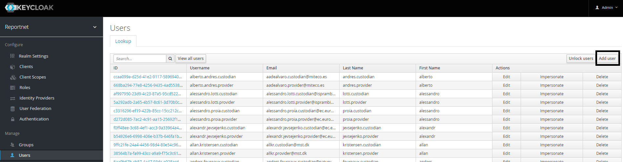

In the form, just type reportnet_user

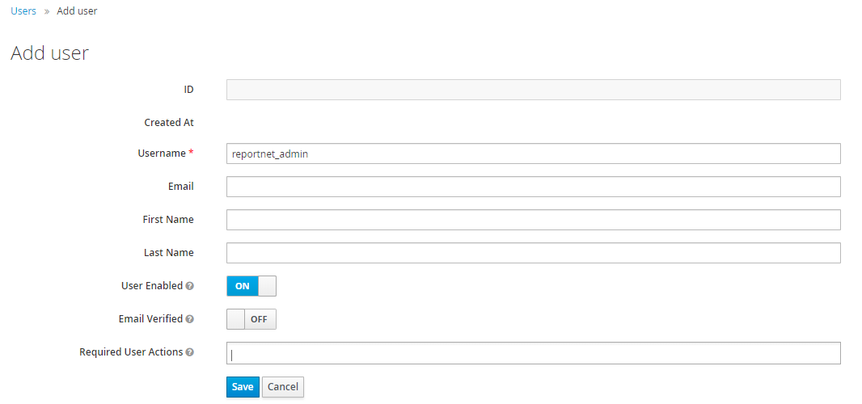

Once it is created it is necessary to create credentials for this user. For this go to tab “Credentials”, fill the form and deactivate “Temporary” check box and click “Reset Password” button.
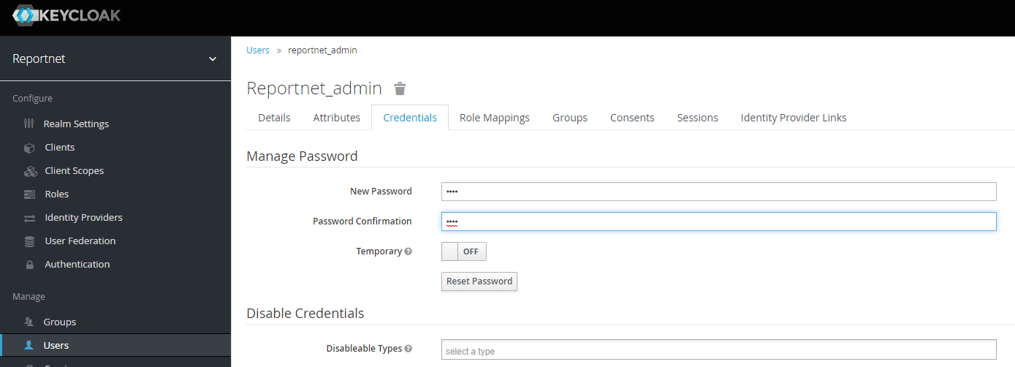
Take note of the password as it will be part of the configuration for UMS Service.

